 LINKEDIN

Product Analysis for Linkedin:

## **Company overview:**

##### The company was founded in December 2002 by ***Reid Hoffman*** and the founding team members from ***Paypal*** and ***Socialenet.com***. Linkedin is a business and employment-focused social media platform that works through websites and mobile apps. It was launched on May 5, 2003. Since December 2016, it has been a wholly owned subsidiary of microsoft. The platform is primarily used for professional networking and career development, and allows jobseekers to post their cvs and employers to post jobs.

### **Product Analysis and Real-World Problems Solved by Linkedin:**

Linkedin allows members (both workers and employers) to create profiles and connect with each other in an online social network which may represent real-world professional relationships. Members can invite anyone( whether an existing member or not) to become a connection. Linkedin can also be used to organize offline events,join groups,write articles, publish job postings, post photos and videos, and more.

Unlike other social networks such as facebooks and myspace, which are often purely recreational, Linkedin emphasizes a user’s professional connections. Users create profile pages that have a structure similar to a resume, in that users can summarize their career, advertise their particular skills, and list their education and employment history. Connections are formed between users when one accepts an invitation from another to join his or her network.

Linkedin allows users to further their careers by searching for jobs, finding connections (even at third hand ) at a particular company, and receiving recommendation from other users. Membership is free however, with payment for premium service, users can receive more profiles in their search results and see full profiles of any linkedin user.

Linkedin ingenious engagement features are it helps in creates a good networks, recruiters can use it to search best employee with exact matching skills as per their requirement, public can research about companies where he or she wants to work and they can connect the already present people in that companies, we can join the various groups that provide knowledge and supports. we can build our brands, linkedin is one of the largest social networking sites for organizations and professionals. For lead generation, it is 277% more effective than facebook and twitter. Users on linkedin can share informative and helpful posts in various formats to engage with their network and provide value.

In conclusion, Linkedin has established itself as a powerful and multifaceted platform with a primary focus on professional networking and career development. It has grown to become the go-to social media platform for professionals across various industries.

# **TOP FEATURES OF LINKEDIN**

### **Profile creation and management:**

* + Users can create a detailed professional, similar to a digital resume. It includes sections for work experience, education, skills,certifications, and recommendation.
  + Users can upload a profile picture and write a compelling headline summarizing their professional identity.

### **Networking:**

* + Linkedin allows users to connect with other professionals, colleagues,classmates,mentors, and industry peers.
  + Users can send connection requests,accept invitations, and follow individuals or companies to stay updated on their activities.

### **Job Search:**

* + Job seekers can use linkedin to search for job openings based on various criteria such as location, industry,job title, and company.
  + Users can apply for jobs directly through the platform or save job listings for later.

### **Company Pages:**

* + Companies can create dedicated linkedin pages to showcase their products, services,company culture, and job opportunities.
  + Users can follow company pages to receive updates and insights about the organization.

### **Analytics:**

* + Linkedin provides users with insights into profile views and posts reach, allowing them to track their online presence and engagement.

### **Education and Learning:**

* + Linkedin Learning offers a vast library of online courses, tutorials, and video content on topics ranging from professional skills to personal development.
  + Users can earn certificates and badges upon course completion.

### **Events:**

* + Users can discover and attend professional events,conferences,webinars, and workshops in their field of interest.This feature facilitates networking and learning opportunities.

### **Resume Builder:**

* + Linkedin offers a resume builder tool that allows users to create a professional-looking resume based on their profile information.
* **Job Postings:**
  + Employers can post job openings on linkedin, and job seekers can apply directly through the platform, making it a popular tool for recruitment.

### **Lead Generation:**

* + For business, Linkedin offers tools for lead generation and advertising, helping them reach their target audience effectively.

### **Talent Solutions:**

* + Linkedin provides tools for recruiters and HR professionals to find and hire top talent efficiently, including tools for applicant tracking and talent acquisition.

### **Case Study: Real-World Problems and Linkedin's Innovative Solutions.**

As of my last knowledge update in September 2021, linkedin has been actively working on various innovative solutions to address real-world problems related to professional networking, talent acquisition, and skill development. While I cannot provide information on developments beyond that date, I can outline some of the real-world problems Linkedin has been addressing and the innovative solutions they have been implementing up to that point.

#### **Job Matching and Recruitment:**

**Problem**: One of the primary challenges in job matching and recruitment is the overwhelming amount of information available, leading to difficulties in filtering relevant opportunities or candidates.

**Solution**: LinkedIn addresses this problem through its recommendation algorithms, which analyze user profiles, connections, and preferences to suggest job openings and candidates that are a good match. Additionally, LinkedIn provides personalized job alerts and notifications to help users stay updated on relevant opportunities, streamlining the recruitment process and reducing information overload.

1. **Professional Networking and Relationship Building:**

**Problem**: One common challenge in professional networking on LinkedIn is the difficulty users face in connecting with relevant professionals and maintaining meaningful relationships in a vast network.

**Solution**: To address this challenge, LinkedIn offers various tools and features, including search and recommendation algorithms to help users find and connect with relevant professionals. Users can also engage with their network by sharing updates and participating in discussions. Additionally, LinkedIn provides privacy settings to address concerns about personal information sharing, allowing users to control their online presence while building professional credibility through endorsements, recommendations, and skill showcases.

1. **Diversity and Inclusion:**

**Problem**: In the professional world, there are challenges related to diversity and inclusion, including underrepresentation of minority groups, unconscious bias, lack of diversity in content, accessibility issues, and non-inclusive language, which can create inequities.

**Solution**: LinkedIn has implemented various solutions to promote diversity and inclusion, such as tools for diversity hiring, awareness campaigns on unconscious bias, encouragement of diverse content sharing, platform accessibility improvements, and guidance on using inclusive language in job postings and interactions. These efforts aim to create a more equitable environment for professionals on the platform. However, users also play a vital role in actively promoting diversity and inclusion through their actions and interactions on LinkedIn.

1. **Remote Work and Job Flexibility:**

**Problem**: A common challenge in the remote work landscape is the difficulty job seekers face in finding remote job opportunities, often due to limited visibility and the absence of clear remote work indicators in job listings.

**Solution**: LinkedIn addresses this challenge by providing dedicated filters for remote and hybrid job opportunities, enabling job seekers to easily identify and apply for remote-friendly roles. Additionally, employers have the option to specify remote work options in their job postings, enhancing transparency and simplifying the job search process for remote work enthusiasts.

1. **Content and Thought Leadership:**

**Problem**: A common challenge on LinkedIn is the overwhelming volume of content, which can lead to information overload and make it difficult for users to find valuable insights and establish themselves as thought leaders.

**Solution**: LinkedIn addresses this challenge by employing algorithms that prioritize content based on relevance and user engagement. Additionally, users can actively curate their feeds by following thought leaders and engaging with content that aligns with their interests and expertise, helping them filter and discover the most valuable posts.

1. **Company Branding and Talent Acquisition:**

**Problem**: One common challenge in company branding and talent acquisition on LinkedIn is the limited visibility faced by smaller or lesser-known companies when trying to attract top talent.

**Solution**: LinkedIn addresses this challenge by providing Company Pages that allow businesses to showcase their brand, culture, and values through rich media and by encouraging employees to share company updates and job postings on their personal profiles, thereby increasing brand visibility and attracting potential candidates.

**CONCLUSION:**

In conclusion, LinkedIn has been proactive in identifying and addressing real-world problems in the professional networking, talent acquisition, and skill development domains. By leveraging innovative solutions, LinkedIn has made significant strides in streamlining job matching and recruitment processes, facilitating professional networking and relationship building, promoting diversity and inclusion, supporting remote work and job flexibility, managing content and thought leadership, and enhancing company branding and talent acquisition efforts.

**Schema Description:**

The schema for linkedin involves multiple entities that show different aspects of the platform. These entities include users, posts, connections,work experience, like, recommendations,institute and etc. each entity has specific attributes that describe its properties and relationship with other entities.

**User Entity:**

Users are at the core of linkedin. The user entity contains basic informations about the users:

* **User-ID(primary key):** A unique identifier for each user.
* **Username:** The username for the user’s account.
* **Full_Name:** The full_name displayed at their profile.
* **Email:** The user's email address for account-related communication.
* **User-profile-pic:** The user-profile-pic appears first when someone come to see profile
* **User-Location:** The user_location shows the availability for that location.

**Post Entity:**

Post contains the visual content shared on the platform:

* **PostID (primary key):** A unique identity for each post.
* **User_ID(Foreign Key referencing User Entity):** The user who created the posts.
* **Post**: Which contains image or video content in the form of URL.
* **Post-Date:** The date when the post was posted.

**User-Institution Entity:**

Institution has information about educational background:

* **User-Institution ID(primary key)**: A unique identifier for institutions.
* **User-ID(Foreign Key referencing User Entity):** The user who studied in the institution.
* **Course-ID:** User had studied that course.
* **Start-Date:** Course had started on that Date.
* **End-Date:** Course had ended on that Date.
* **Description:** summary about the course.
* **CGPA:** Marks get into that course.

**User-Skills Entity:**

Skills represent the abilities of users.

* **Users-SkillsID(primary key):** A unique identifier for skills
* **User-ID(Foreign Key referencing User Entity):** The user who has skills
* **Skills-ID:** User has skills

**User-Company Entity:**

Company represent where user has working:

* **Users-company ID(primary key)**: A unique identifier for relation between company and user.
* **User-ID(Foreign Key referencing User Entity):** The user who works in the company.
* **CompanyName:** The company where the user works.
* **Profile:** What is the profile of the user.
* **Start-Date:** when a user joins the company.
* **End-Date:** when the user leaves the company.
* **Salary:** How much a user gets paid.

**Connection Entity:**

Connection represent relation between receiver and sender:

* **connection ID(primary key):** A unique identifier for connection between receiver and sender.
* **Connection-receiver ID:** Identifier for receiver.
* **Connection-Send ID:** identifier for sender.

**Recommendation Entity:**

Recommendation represents a connection or association between a user and endorsements provided by others:

* **Recommendation ID(primary key):** A unique identifier for recommedate of user.
* **RecommendationSend ID:** identifier who sends recommendations.
* **RecommendationReceiver ID:** identifier who receives recommendations.

**LIKE Entity:**

Likes represent user appreciation for posts:

* **Like ID(primary key):** A unique identifier for each like
* **User ID(Foreign Key referencing User Entity):** the user who liked the post.
* **Post ID(Foreign Key referencing User Entity):** The post being liked.
* **LikeDate:** The date when the like was registered.

**Comment Entity:**

Comments enable users to engage in conversations around posts:

* **CommentID (Primary Key)**: A unique identifier for each comment.
* **PostID (Foreign Key referencing Post Entity):** The post being commented on.
* **UserID (Foreign Key referencing User Entity)**: The user who posted the comment.
* **Text**: The text of the comment.
* **CommentDate**: The date when the comment was posted

**Relationships are:**

* **Users post Posts:** Each user can posts multiple posts, and each post is created by a single user. This is a one-to-many relationship between the User Entity and the Post Entity.
* **Users comment on Posts:** Users can comment on multiple posts, and each post can have multiple comments. This is a many-to-many relationship between the User Entity and the Post Entity.
* **Users like Posts:** Users can like multiple posts, and each post can have multiple likes. This is a many-to-many relationship between the User Entity and the Post Entity.
* **Users send connections to other Users:** Users can send connections to multiple users, and each user can receive connections from multiple users. This is a many-to-many relationship between the User Entity (acting as both sender and receiver) and the Connection Entity.
* **User recommedate other Users:** Users can recommend multiple users, and each user can receive recommendations from multiple users. This is a many-to-many relationship between the User Entity (acting as both sender and receiver) and the Recommendation Entity.
* **User has skills:** Each User can have multiple skills, and each skill can be associated with multiple users. This is a many-to-many relationship between the User Entity and the Skills Entity.
* **User works in companies:** Each user can work in multiple companies, and each company can have multiple users. This is a many-to-many relationship between the User Entity and the Company Entity.
* **Users can study in Institutions:** Each user can study in multiple institutions, and each institution can have multiple users. This is a many-to-many relationship between the User Entity and the Institution Entity.

## **ER Diagram**

The ER diagram definition provides a high-level overview of the entities and their relationships with a simplified linkedin database schema.

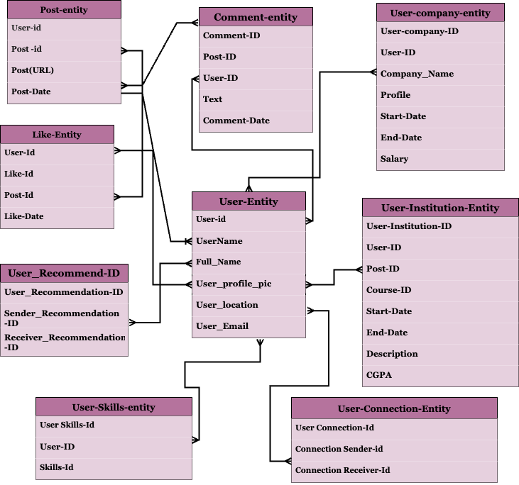

**CONCLUSION**

In conclusion, LinkedIn stands out as a pivotal platform in the professional networking and career development landscape, offering a multifaceted approach to connecting individuals, businesses, and opportunities.The platform's unique features, such as profile creation and management, networking capabilities, job search functionalities, and educational resources, contribute to its significance in the professional sphere. LinkedIn's commitment to addressing real-world challenges is evident in its solutions for streamlining recruitment processes, promoting diversity and inclusion, supporting remote work, and enhancing company visibility. LinkedIn's success can be attributed to its dedication to providing value to users through continuous refinement and expansion of its features. As LinkedIn continues to evolve, its role in shaping the future of professional networking and career development is likely to remain prominent.